ZhiWei Qiu 143304186

Zqiu12@myseneca.ca

**(WEB322) -Web Programming Tools and Frameworks**

Assignment4-6

**Table of content**

**Summary p2**

**Sign up p3**

**Log in (authentication) p5**

**Administrator mode p7**

**Edit room p7**

**Create a room p8**

**Normal user page p9**

**Book a room p10**

**Display room list for visitor p10**

**Search room p11**

**Overview**

**this project is based on previews assignment 1-3. The added functions include:**

1. **sign up a new user**
2. **log in as normal user or administrator**
3. **administrator mode can create a new room include basic information such as title, price, location, description and upload a picture. Also, the administrator can edit room information.**
4. **Normal user mode can book a room and view the booked rooms list**
5. **All user include normal user, administrator or visitor can see a room page which contains all rooms is uploaded.**

Github: <https://github.com/castielqiu/web322_assignment4-6>

Heroku: https://airbnb4to6.herokuapp.com/

Sign up form

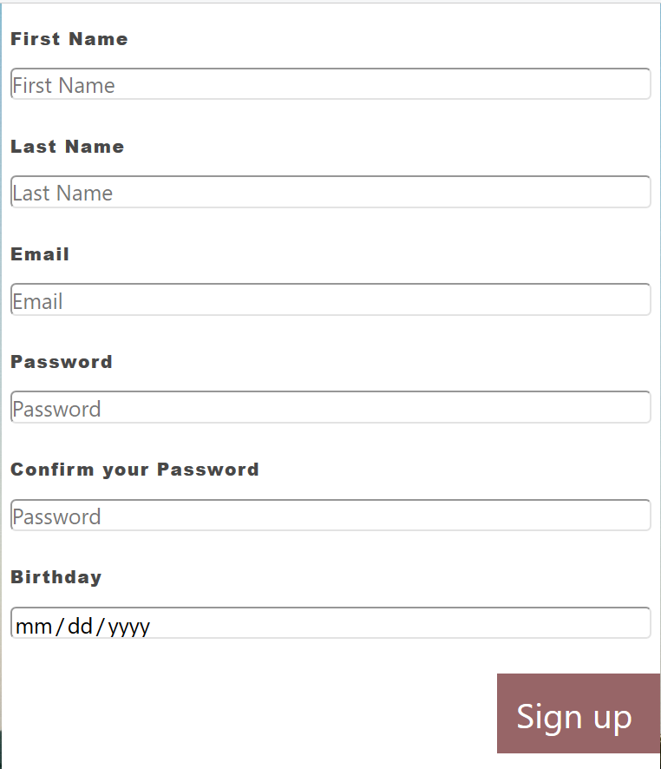

After click “Sign up”, the app will check:

1. all fields must be filled
2. Email address is unique to each user. If Email address has been used by previous user then new user needs a new Email address to register.
3. Password and confirm password must be the same

If either one of the rules not meet then will lead to error message for that field.

Below are error messages:

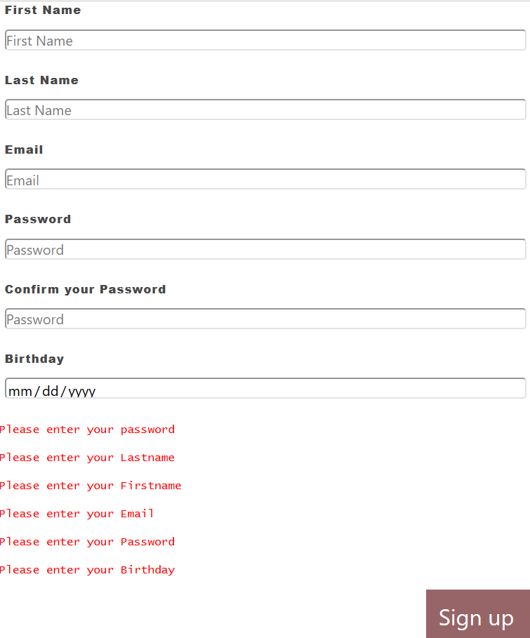

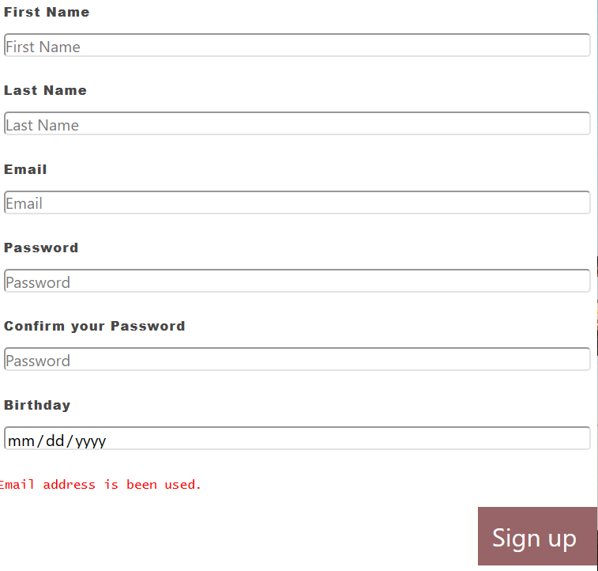 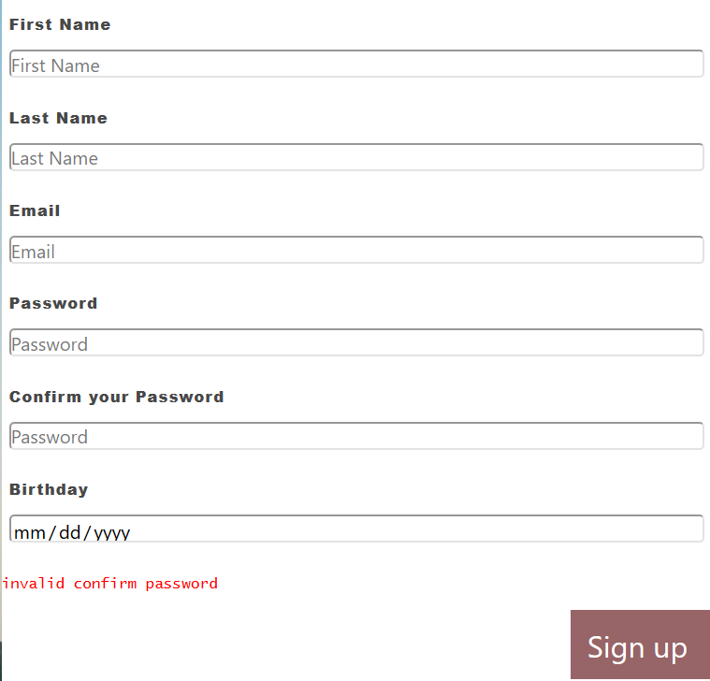

Once all requirements meet new user will add to database then direct to log in page.

Also user password we use bcryptjs to hash and save in database

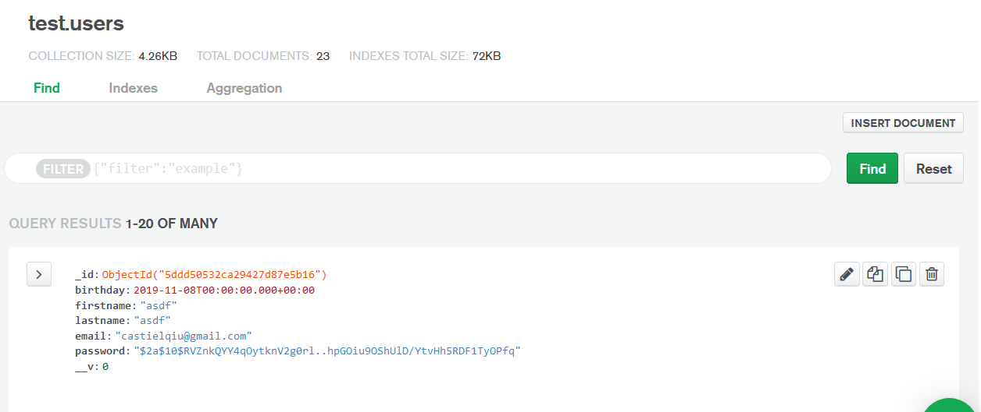

Log in Form

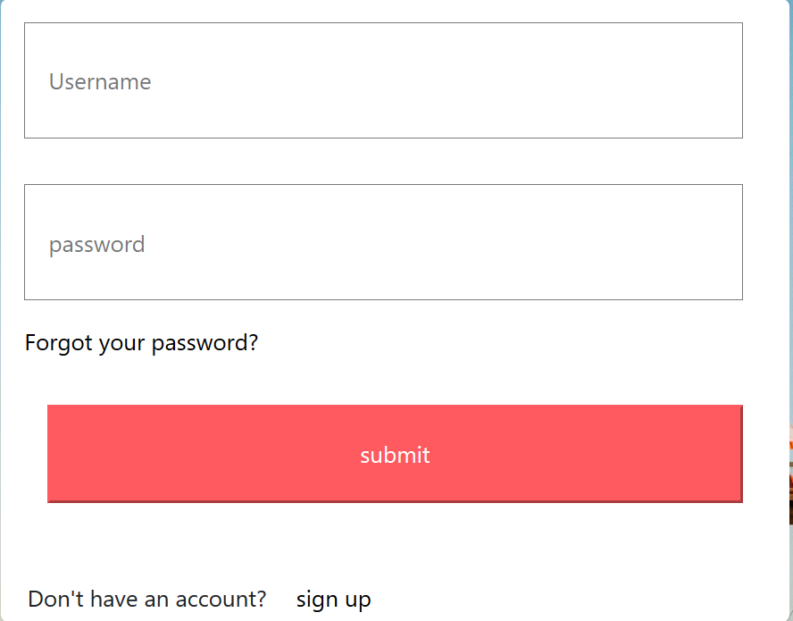

In this page user log in with their email and password. Either Email address or password is wrong,

the web page will show error message. If visitor doesn’t have account, at the bottom of form also has a “sign up” link can direct to sign up page.

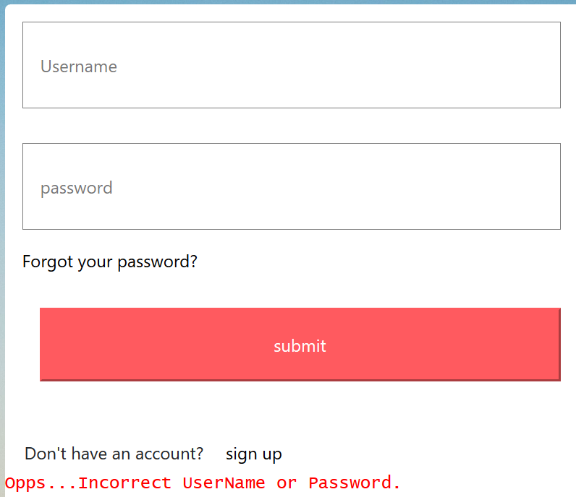

If visitor hasn’t register yet, the web page navigation bar will show “sign up” and “log in” on the right



Once user successful logged in, the navigation bar will show “log out”. The “sign up” and “log in” will disappear once user log out, the session will be destroyed.



The router is protected.

Visitor will direct to log in page if he tries to access create room, edit room or book page without log in.

If user have passed the authentication then the web will direct user to either user page or administrator page

We manually change a user to administrator

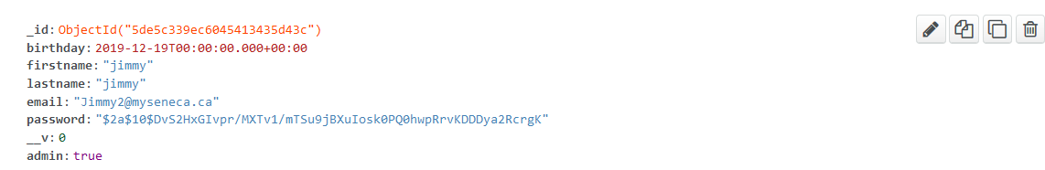

Administrator page

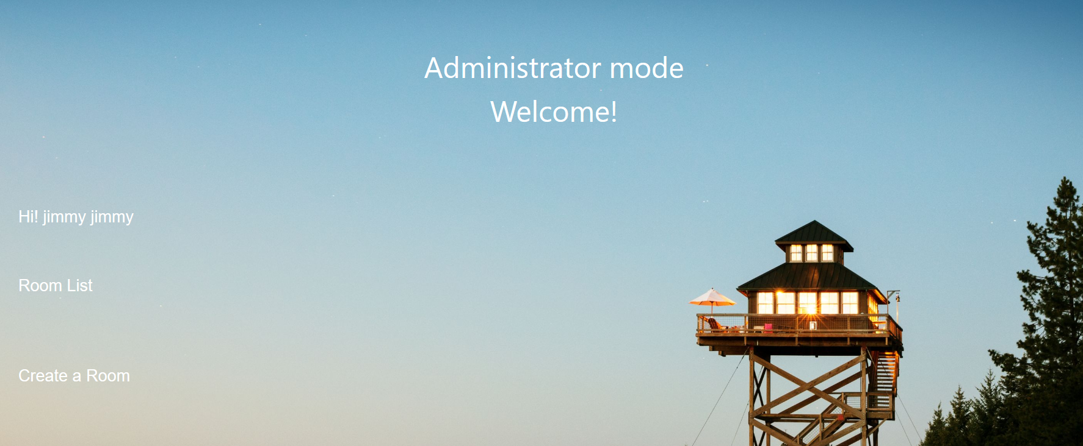this page contains 2 links.

1.“Room list” will direct to room page which contains all the uploaded room information.

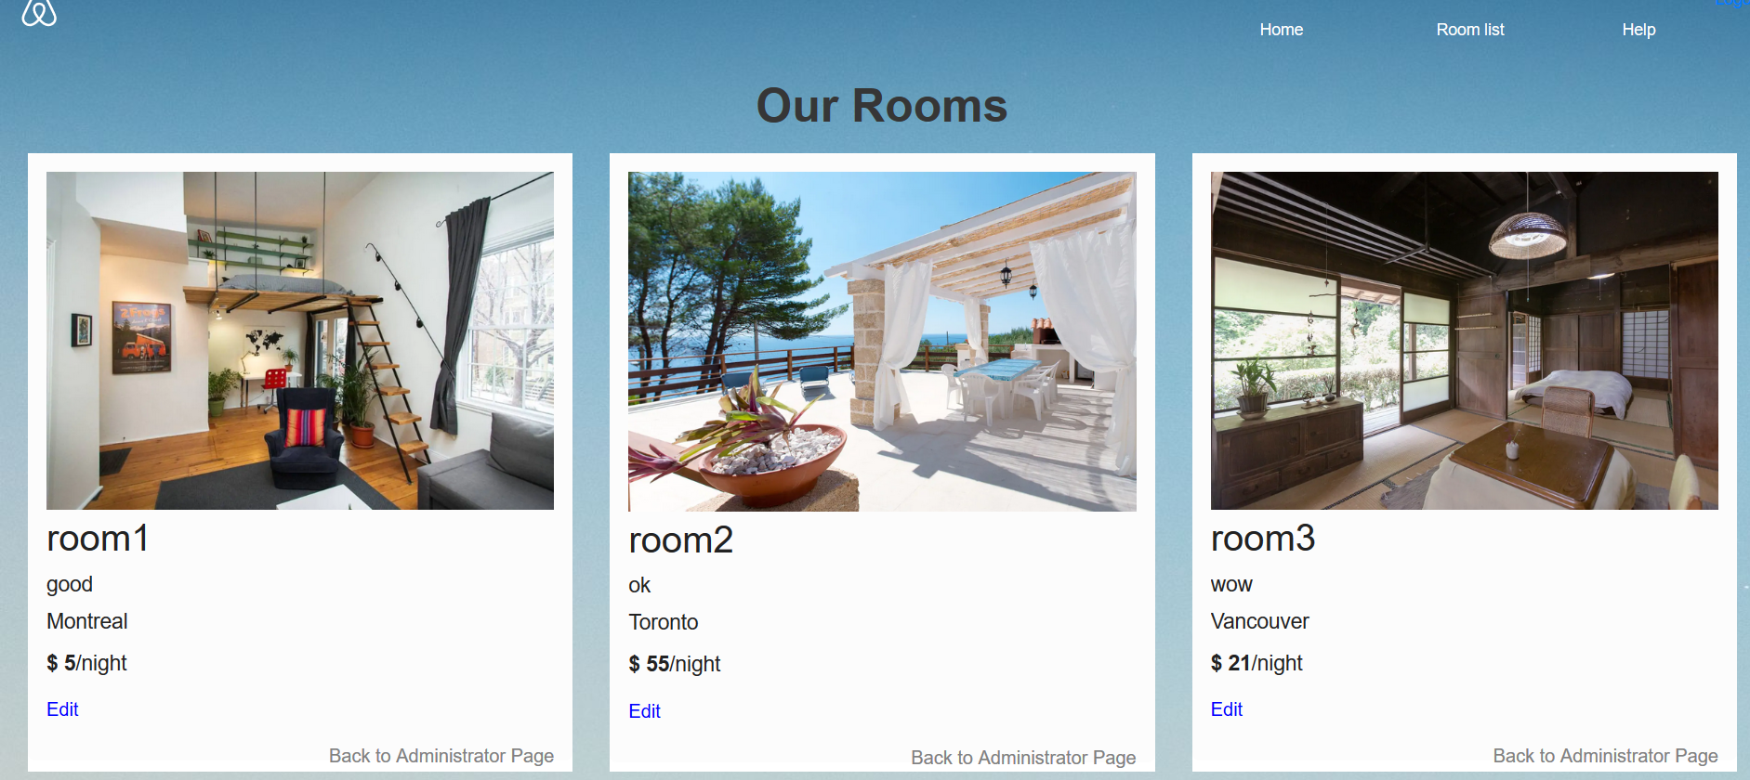

In this page, “Edit” will direct user to edit page

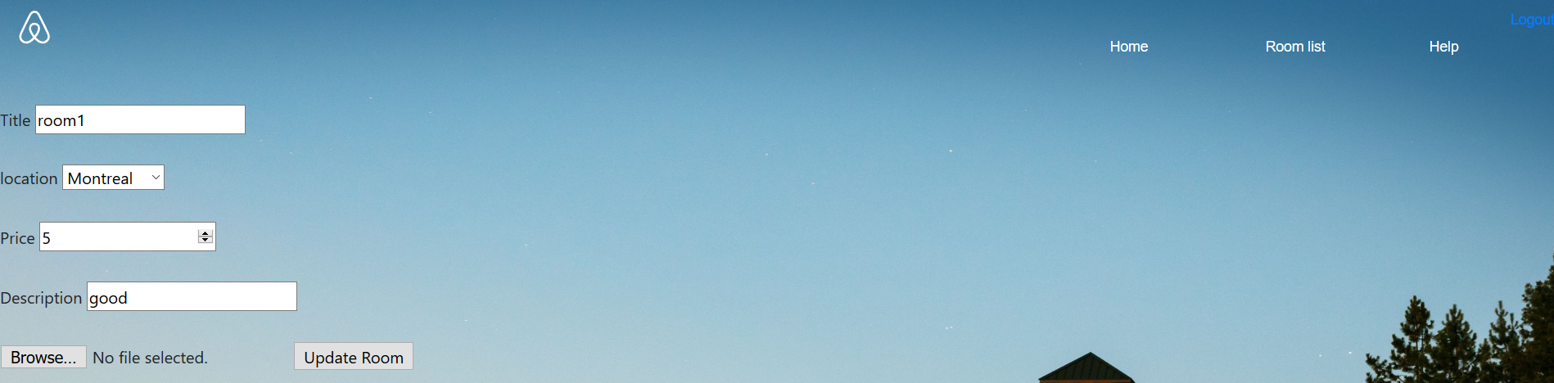

This page requires user re-upload picture and limit the types of file to upload.

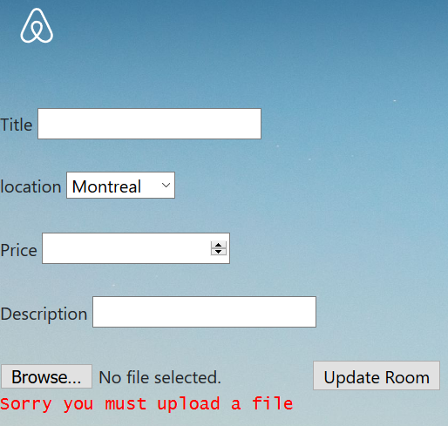

After edit room information and upload picture, click” update room”, web app will direct user back to room page and user can see the updated room information.

In room display page, we can click “back to administrator page” to go back to admin page.

2. “Create a room” will direct user to a “add page”.

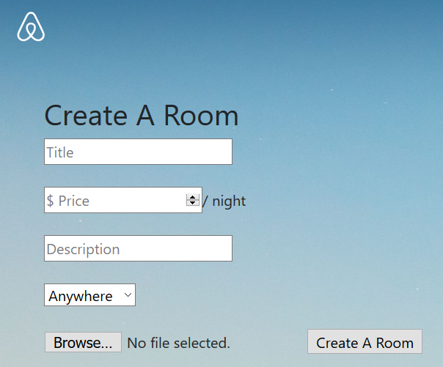

All fields must be filled before hit the “Create a Room”

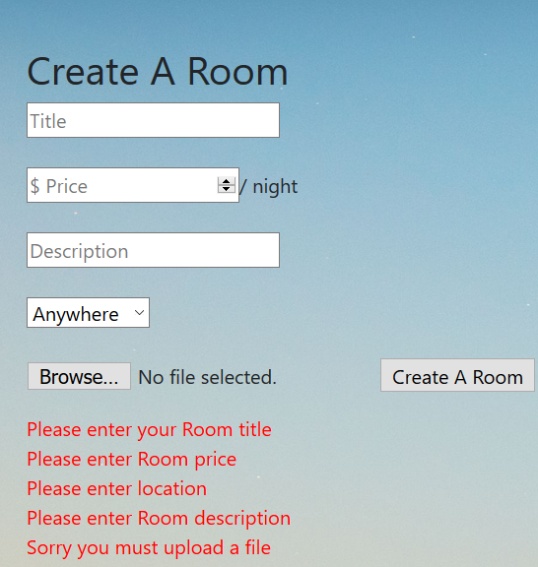

After successful create a room, user will direct to room display page.

Normal user Page

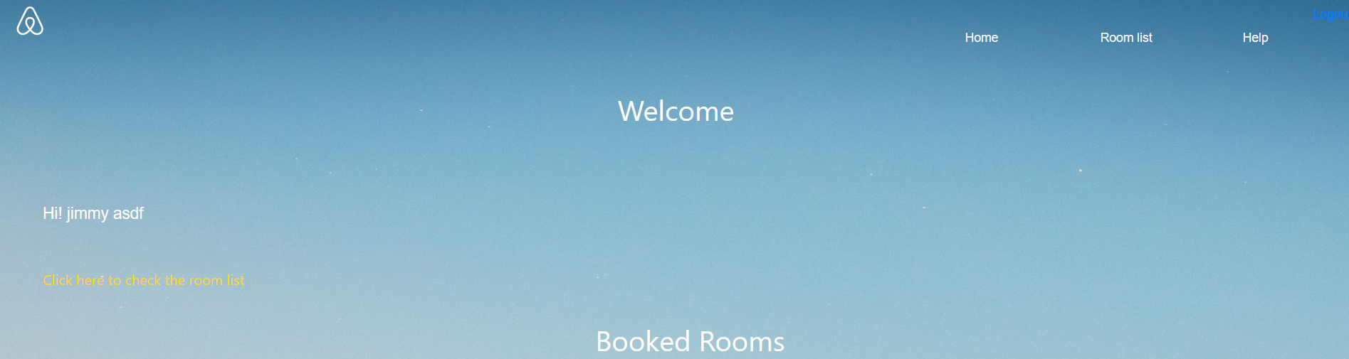

In his page, we can click “Click here to check the room list” to check all the room information, also under the booked Rooms, this page will show all booked rooms information.

After click the ““Click here to check the room list””, will direct user to room display page. Different from admin mode, this room page will show booking button instead of edit.

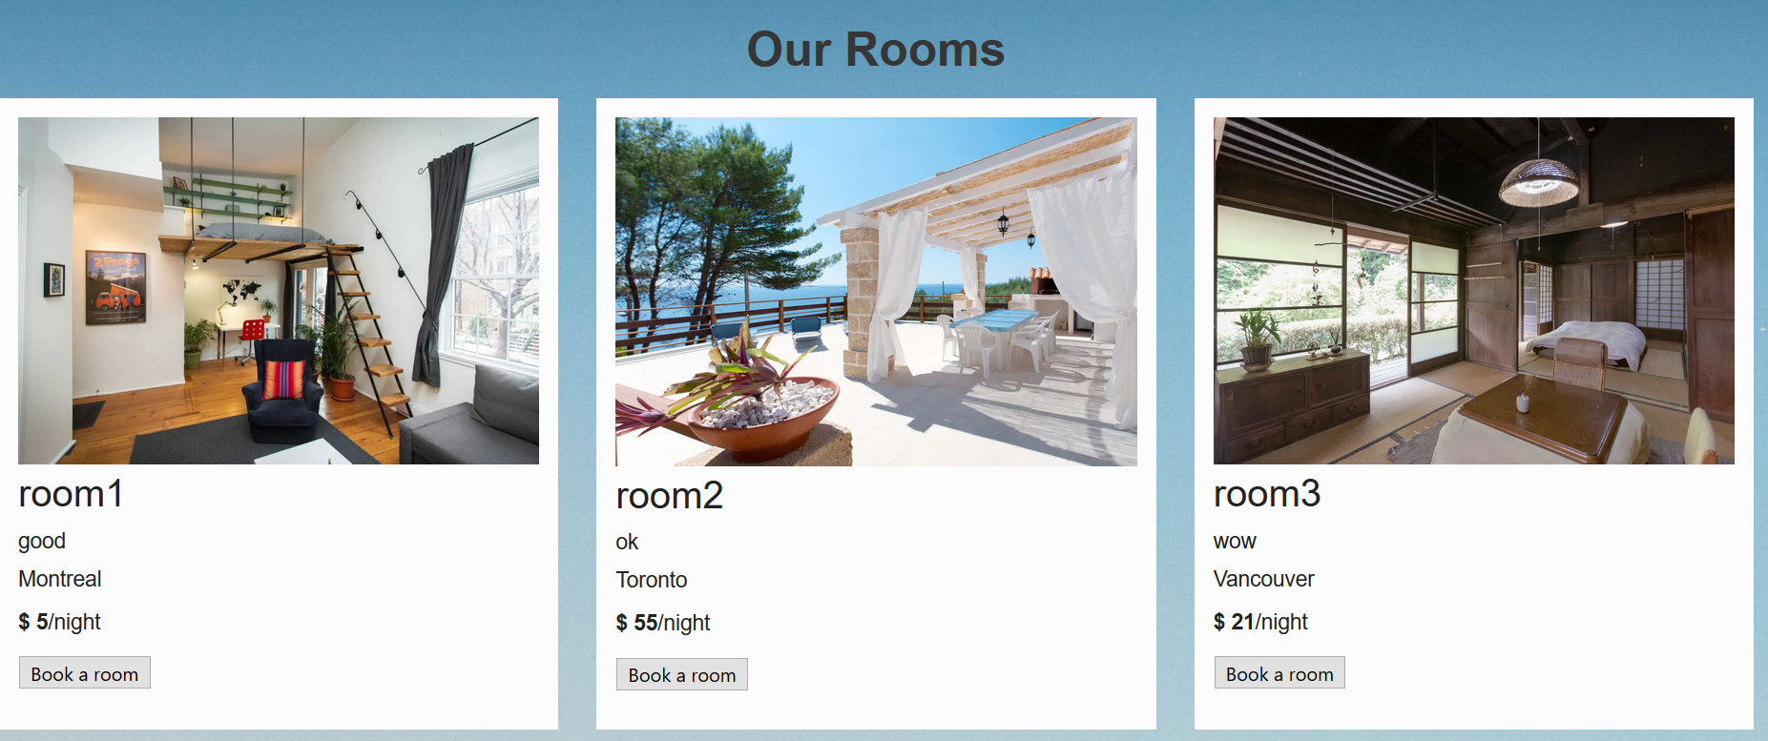

After click” book a room”. Web will direct user back to user page and display booked rooms.

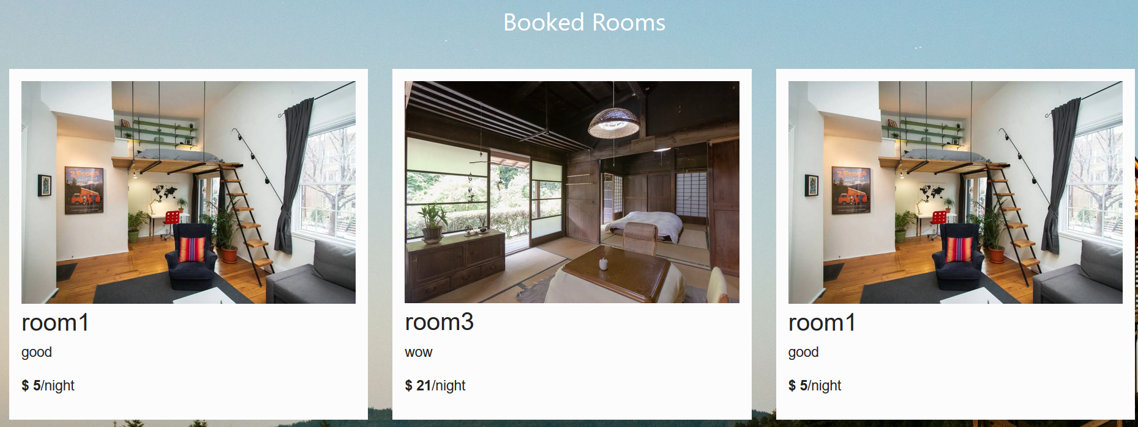

Visitor without log in still can see the room list in room display page. In this case, under room information will show “please log in” button direct visitor to log in.

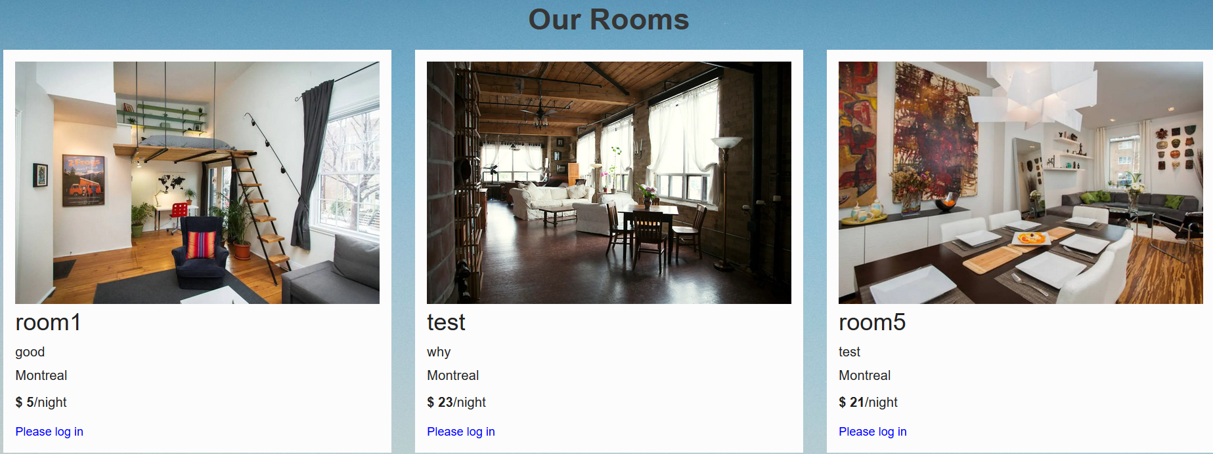

Visitor also can search a room by selecting the location, click search.

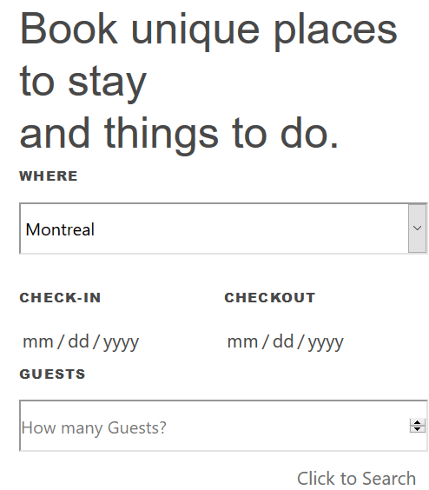

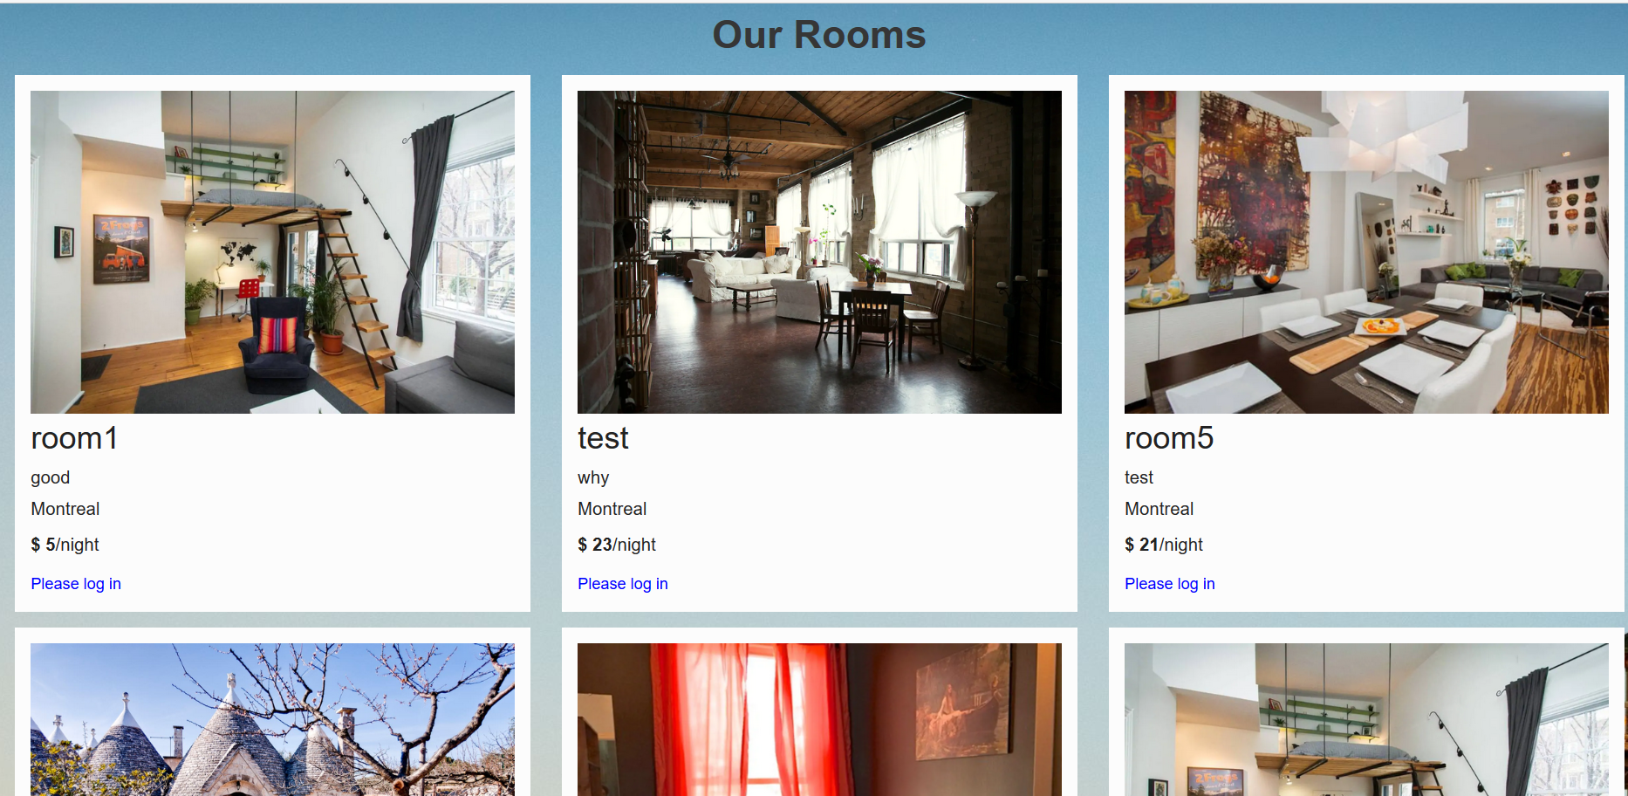

Direct user to room list page and only show the rooms locate at the selected location.